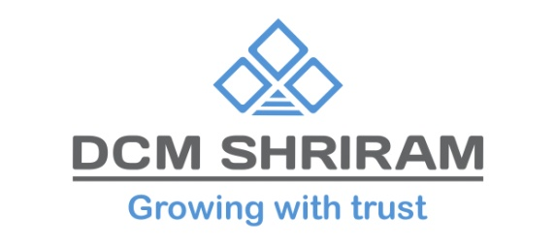
DCM Shriram Ltd Signs MoU with Institute of Chemical Technology, Mumbai for R&D Collaboration
New Delhi, 27th May 2024: DCM Shriram Ltd, India’s second largest Chlor Alkali manufacturer, signed a Memorandum of Understanding with the prestigious Institute of Chemical Technology (ICT), Mumbai. This strategic collaboration aims to advance research and development (R&D) in the chemical industry, leveraging ICT's academic prowess and DCM Shriram's industrial expertise.
The MoU was signed in a formal ceremony attended by Prof. Aniruddha Pandit, Vice Chancellor of ICT Mumbai, and Dr. Debabrata Rautaray, Chief Product Development & Innovation Officer of DCM Shriram Chemicals.
This collaboration will see ICT Mumbai undertake specialized R&D projects tailored to DCM Shriram’s objectives. Projects will be conducted under the supervision of designated experts from ICT, ensuring high standards of academic and research rigor. DCM Shriram Ltd will work closely with ICT to align project goals and timelines, facilitating a seamless integration of research outcomes into practical applications.
Dr. Debabrata Rautaray, Chief Product Dev. & Innovation Officer, DCM Shriram Chemicals expressed his enthusiasm, stating, "Partnering with ICT Mumbai aligns with our commitment to pioneering cutting-edge solutions and enhancing our product development capabilities. We are confident that this synergy will yield significant advancements."
Prof. Aniruddha Pandit, Vice Chancellor, ICT added, "This collaboration with DCM Shriram Ltd presents a unique opportunity to merge academic research with industry practices, fostering innovation and development in the chemical sector."
About DCM Shriram Ltd:
DCM Shriram Ltd. is a leading business conglomerate with business portfolio comprising of primarily Chlor-Vinyl Business – Caustic Soda, Chlorine, Calcium Carbide, Aluminum Chloride, PVC Resins, PVC Compounds, Power and Cement; Agri-Rural Business – Sugar including distilleries, Farm Solutions, Urea, and Hybrid Seeds; and Value Added Business Fenesta Building Systems - UPVC & Aluminum Doors and Windows.
About Institute of Chemical Technology, Mumbai:
Established on October 1, 1933, as the University Department of Chemical Technology (UDCT) of the University of Bombay, the Institute of Chemical Technology (ICT), Mumbai, has grown into a premier institution dedicated to education, research, and industrial collaboration in chemical engineering and technology. Over the years, it has achieved full autonomy, becoming a Deemed-to-be-University in 2008.
ICT is recognized for its excellence, holding an A++ grade from the National Assessment and Accreditation Council (NAAC) and ranking among India's top engineering and pharmacy institutes. It has also been granted Elite Status and Centre of Excellence by the Government of Maharashtra.

